**IoT Edge Server on Smart Manufacturing**

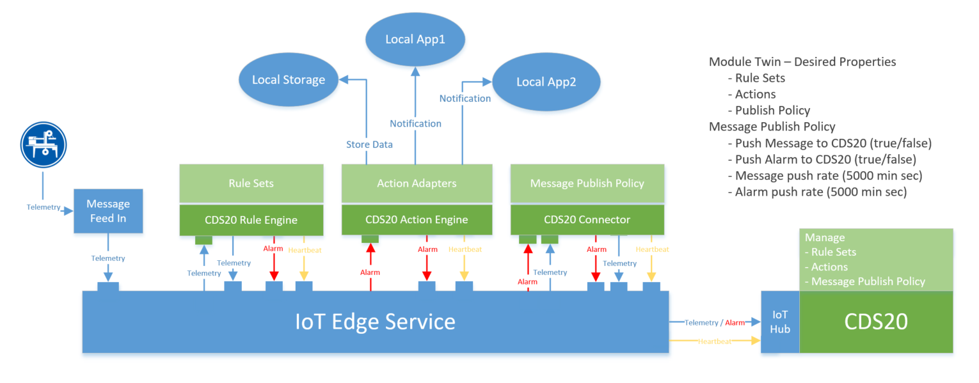

1. CDS20 Rule Engine
   1. Send heartbeat to CDS20 (define interval)
   2. Rule Engine & Rule Sets
      1. Implement Rule Engine (ASA or Current, To be evaluate)
      2. Web UI on CDS20 to management Rule Sets associated with this equipment
      3. Deploy Rule Sets via Module twin - desired properties
   3. Execute rules matching, and generate Alarm Message.
      1. Alarm Message including Actions tag.
2. CDS20 Action Engine
   1. Send heartbeat to CDS20 (define interval)
   2. File Adapter
      1. When Alarm Message tags File Action.
      2. Linux file system
      3. Windows file system
      4. Allow to define files store path pattern: {deviceId}/{yyyy}/{mm}/{dd}/messageUniqueId.json
   3. Web API Adapter
      1. When Alarm Message tags Web API Action
      2. Auth (None, Basic)
      3. Method: POST
      4. Encode: urlencode-form, multi-part, json
   4. Deploy Actions' configuration via Module twin - desired properties
3. CDS20 connector
   1. Send heartbeat to CDS20 (define interval)
   2. Push message to CDS20 (true/false) on Message Level
      1. Message push rate (5000 ms) on Message Level
   3. Push alarm to CDS20 (true/false) on Alarm Rule Level
      1. Alarm push rate (5000 ms) on Alarm Rule Level
   4. Deploy policy configuration via Module twin - desired properties

Questions:

1. Does Edge Server support message route for 1 input and 2 output?

For example: when a Telemetry send from first module (A), is it OK to route it to multiple modules (B, C, D)?

1. Does Edge Server come with out of box feature to monitoring module running health? Such as heartbeat signal.